Murray and Emu - Learning From Home Plan
Term 2 Week 1

 | Monday | Tuesday | Wednesday | Thursday | Friday
8:55am - 9:55am |  |  | English  Writing - Planning  Look at the image provided to inspire your story.  Writing - Composing  Compose your story.  Use your planning sheet to guide your story.  Remember to:  - write in full sentences  - start a new paragraph for your orientation, complication and resolution  - tick off each word as you include them in your story | English  Writing - Composing  Compose your story.  Use your planning sheet to guide your story.  Remember to:  - write in full sentences  - start a new paragraph for your orientation, complication and resolution  - tick off each word as you include them in your story | English  Writing - Revising and Editing  Using a coloured pen you are going to revise and edit your work.  To revise your work:  - Include adjectives  - Use interesting sentence starters  - Use powerful words  Refer to the Writing Process Slides for ideas  To edit your work:  - spelling mistakes?  - punctuation check?  - does it make sense?  Writing: Please upload this writing sample to Seesaw (ideal) or send it via email so that I can provide feedback.
9:55am-  11:00am |  |  | Complete Wednesday on your literacy Grid | Complete Thursday on your literacy Grid | Complete Friday on  your literacy Grid
Break
11:50am-  12:50pm |  |  | Mathematics  Tasks:  - Matific  - Maths grid activity  - Number of the Day  (worksheet, or complete on Seesaw). Too choose your number, roll a dice (roll a dice multiple times for more difficult mu-digit numbers)  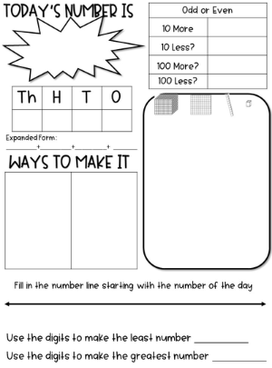 | Mathematics  Tasks:  - Matific  - Maths grid activity  - Number of the Day | Mathematics  Tasks:  - Matific  - Maths grid activity  - Number of the Day
12:50 - 1:50 |  | . | Creative Arts: Art  Listen to the following stories:  Sky Colour: https://www.youtube.com/watch?v=ehfb86HoEzA  I Don’t Draw I Colour: https://www.youtube.com/watch?v=DUlP6xiCW2k  Then  Use the attachment Art Week 1 T2 to complete the art lesson. Remember to post your finished artwork on Seesaw.  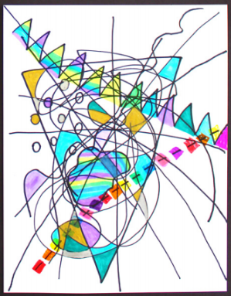 | PDHPE: Dance  DanceFever MultiSport  https://www.youtube.com/watch?v=iiN2fYbC0vc​ | STEM (Science)  Get creative, use your imagination and think outside the box:  Listen to the Story – The Most Magnificent Thing by Ashley Spires https://www.youtube.com/watch?v=UM8oN4yzJqw  Complete the assigned task on Seesaw: Curious Moment: What can you create?  When you post your invention on Seesaw please include:  - Your inventions name  - How you made it?  - What it is used for?  - Use lots of descriptive language
Break
2:20pm-  3:00pm |  |  | Personal Development, Health Physical Education (PDHPE)  Mindfulness: Smiling Minds App (Parents to download)  https://www.smilingmind.com.au/  or  Cosmic Kids Yoga  www.cosmickidsyoga.com | At Home Activity Grid  (emailed to parents along with this Timetable) | Lego Stem Challenge!  Choose and complete a challenge from the Lego Challenge.

For further activities, refer to the Department of Education website on Home learning - https://education.nsw.gov.au/teaching-and-learning/curriculum/learning-from-home

If you require offline copies of the work (hardcopies) please email Anthea Bell (anthea.bell4@det.nsw.edu.au) with your name, your child’s name and class and full address.

