Platypus - Learning From Home Plan
Term 2 Week 2

 | Monday | Tuesday | Wednesday | Thursday | Friday
English Focuses
Our sight words are: I, am, a, at, can, see, mum, dad, look, the, this, is, went, and, can
Our writing focus is: finger spaces and “If I can say it I can write it” (verbalising and then attempting to write statements)
8:55am - 9:55am | English  Writing: Talk to someone in your house about your weekend, and then write a 1-2 sentence recount.  Hint: While developing their independent writing, it may help your child to reconstruct a cut-up sight word sentence and then copy that writing.  Phonics:  go to:  www.soundwaveskids.com.au and enter code flat997.  Go to: Phase 1 Sound Units and consolidate familiar sounds  s a t p i n m g p l r o d b | English  Writing: Story of the Week  Pete the Cat: I Love My White Shoes  - Watch the video and listen to the story:  https://youtu.be/fj_z6zGQVyM  - Activity: Write and draw about your favourite part.  eg. I like Pete the Cat. I like that his shoes change colours.  Decorate Pete’s shoe on Seesaw. | English  Writing: Spend a few minutes viewing the elephant at Taronga Zoo via their live zoo cams: https://taronga.org.au/taronga-tv#animallivecams  - Activity: Use your sight words to write and draw about the animals at the zoo.  eg. I am at the zoo.  Look at the elephant. | English  Writing: Story of the Week  Pete the Cat: I Love My White Shoes  - Watch the video and listen to the story:  https://youtu.be/fj_z6zGQVyM  - Activity: Write the story in your own words.  Please upload this writing sample to Seesaw (ideal) or send it via email so that I can provide feedback. | English  Writing: Use your sight  words to write and draw  about a topic of your  choosing.  eg. I am at the park.  Look at the swing.  Phonics:  go to:  www.soundwaveskids.com.au and enter code flat997.  Go to: Phase 1 Sound Units and practise these new sounds:  f v k e
9:55am-  11:00am | Complete Monday on your Literacy Grid | Complete Tuesday on your Literacy Grid | Complete Wednesday on your Literacy Grid | Complete Thursday on your Literacy Grid | Complete Friday on  your Literacy Grid
Break
11:50am-  12:50pm | Mathematics  Tasks:  - Matific  - Maths grid activity  - Number of the Day (worksheet, or complete on Seesaw). Too choose your number, roll a dice (roll a dice multiple times for more difficult mutli-digit numbers)  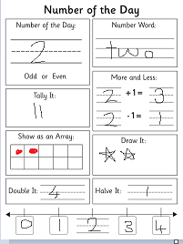 | Mathematics  Tasks:  - Matific  - Maths grid activity  - Number of the Day | Mathematics  Tasks:  - Matific  - Maths grid activity  - Number of the Day | Mathematics  Tasks:  - Matific  - Maths grid activity  - Number of the Day | Mathematics  Tasks:  - Matific  - Maths grid activity  - Number of the Day
12:50 - 1:50 | Creative Arts: Nature & Art (on Seesaw)  View the Nature Walk art video on Seesaw and make an artwork using things you find in nature.  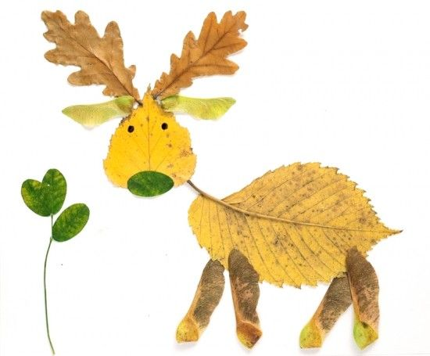 | History/ Geography  Sign into Inquisitive to complete assigned tasks. | Cooking  Instructional video uploaded to Seesaw | Sport  DanceFever MultiSport  www.youtube.com/c/dancefevermultisport | STEM Get creative, use your imagination and think outside the box:  The Ryde School chickens are sending you on a mission….to protect their eggs! Are you up for the challenge?  Complete the assigned task on Seesaw – The Egg Protection Program.  You will need:  Eggs  Resources to protect the egg: tissues, material, cotton wool, bubble wrap etc.
Break
2:20pm-  3:00pm | Art  Imagination Art (Seesaw) | Sport Be Skilled Be Fit  https://www.youtube.com/channel/UCPgYPIrnWPXbuR-C8asgXtw | Personal Development, Health Physical Education (PDHPE)  Mindfulness: Smiling Minds App (Parents to download)  https://www.smilingmind.com.au/  or  Cosmic Kids Yoga  www.cosmickidsyoga.com | At Home Activity Grid  (emailed to parents along with this Timetable) | Lego Stem Challenge!  Choose and complete a challenge from the Lego Challenge.

For further activities, refer to the Department of Education website on Home learning - https://education.nsw.gov.au/teaching-and-learning/curriculum/learning-from-home

If you require offline copies of the work (hardcopies) please email Anthea Bell (anthea.bell4@det.nsw.edu.au) with your name, your child’s name and class and full address.

